Serenity Power Announces Michael Pastula as Chief Technology Officer
May 11, 2026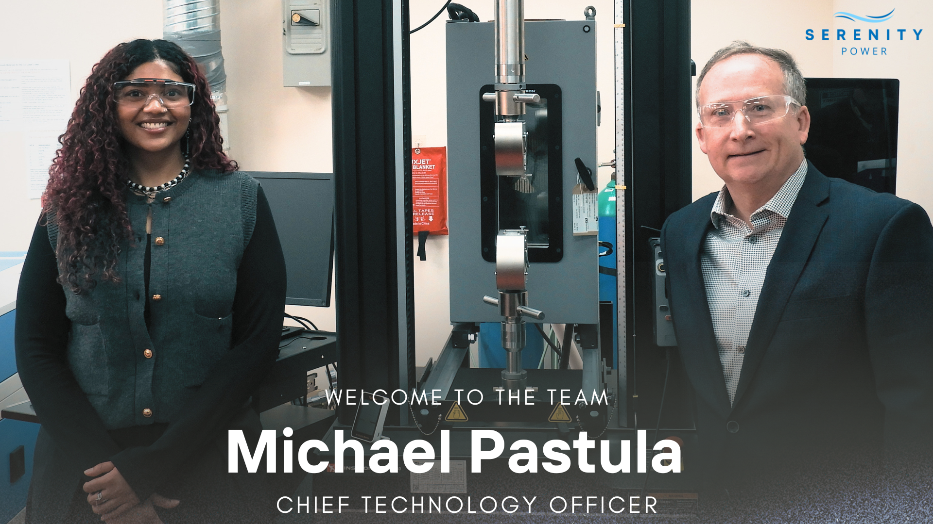
Toronto, ON and Calgary, AB — Serenity Power is pleased to announce the appointment of Michael Pastula as Chief Technology Officer (CTO), leading the company’s technology and product development initiatives as it accelerates toward commercialization.
Michael brings extensive experience in fuel cells, mechanical engineering, system development, and scalable product design. In his role as CTO, he will oversee the development and scale-up of Serenity Power’s Solid Oxide Fuel Cell (SOFC) platform, guiding the company from prototype development through commercialization of scalable clean energy systems.
“Michael has already played a critical role in advancing our technology development, and we are thrilled to officially welcome him into this executive leadership position,” said Aleisha Reese Cerny, CEO and Co-founder of Serenity Power. “His technical expertise, leadership, and product development experience will be instrumental as we continue to build scalable clean energy systems designed to decarbonize industrial operations and remote power generation.”
As CTO, Michael will lead Serenity Power’s end-to-end technical roadmap, including stack and system architecture, manufacturability, supplier integration, and technical team growth.
Michael commented, “I am excited to join and contribute to Serenity’s advanced metal-supported solid oxide technology. Reliable local electrical power needs are intensifying everywhere, and Serenity’s SOFC products are an important and needed future solution”. He also added that Serenity’s approach, starting with low kW product markets, reduces commercialization barriers and accelerates time to market.
Michael’s appointment marks a significant milestone for Serenity Power as the company continues building next-generation fuel-flexible SOFC systems capable of delivering reliable, efficient, and low-emission power solutions for industrial and off-grid applications.
About Serenity Power
Serenity Power is a Canadian clean technology company developing advanced Solid Oxide Fuel Cell (SOFC) systems to provide affordable, reliable, and low-emission power solutions for industrial, remote, and energy-intensive applications. The company is focused on accelerating the transition to cleaner distributed energy infrastructure through fuel-flexible, high-efficiency power generation technologies.
Media Contact
Aleisha Cerny, CEO, Serenity Power
contact@serenitypower.ca

