Serenity Power Awarded $231,792 Industry Grant from NGIF Accelerator to Advance Clean, Compact Fuel Cell Technology for the Energy Sector
Funding will support the development and field testing of Serenity Power's compact solid oxide fuel cells, delivering reliable low-emission power for natural gas operations, remote sites, and industrial applications.
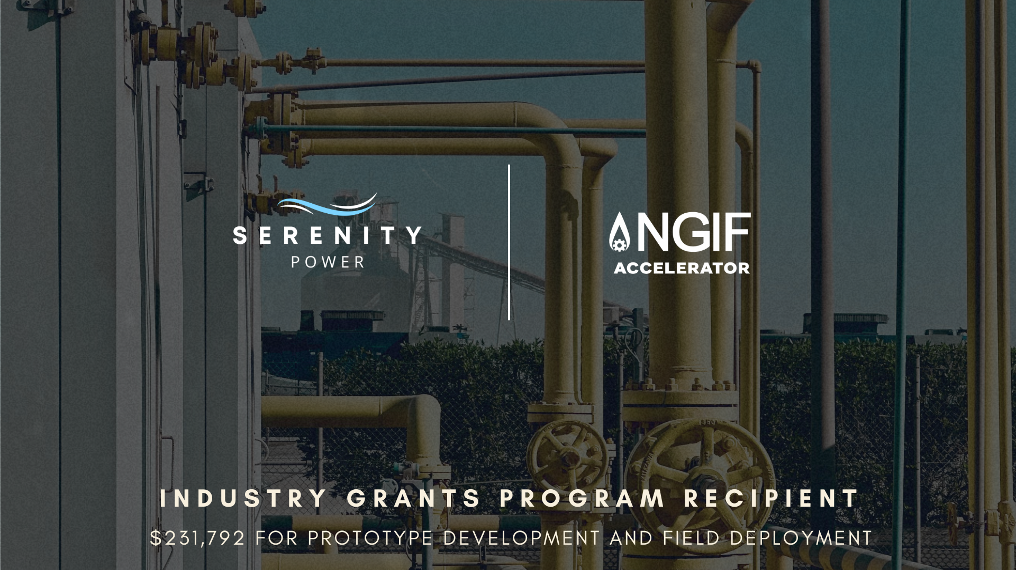
CALGARY, AB (April 23, 2026) — Serenity Power, a cleantech startup developing compact, fuel-flexible solid oxide fuel cell (SOFC) systems, today announced it has been awarded a $231,792.53 grant from NGIF Accelerator through its Industry Grants Program. The funding will accelerate the development and field testing of Serenity Power's next-generation fuel cell technology—a clean, dependable alternative to diesel, natural gas generators and thermoelectric units for the energy sector.
Serenity Power's compact SOFC systems produce electricity and heat exactly where they are needed and can run on natural gas, hydrogen, or a blend of both. They are purpose-built to deliver reliable, low-emission power at natural gas stations, remote monitoring sites, industrial facilities, and other locations where traditional power sources are costly, carbon-intensive, or unreliable.
The NGIF Accelerator grant will fund the build and real-world testing of Serenity Power's 100W prototype within the next year. Learnings from the field trials will inform the development of larger 1kW systems designed for industrial operators and remote communities, with a longer-term roadmap toward utility-scale deployments that help reduce emissions, lower operating costs, and modernize energy infrastructure across the sector.
“This industry grant is a significant milestone for Serenity Power, and NGIF Accelerator's support goes well beyond the funding itself,” said Aleisha Cerny, CEO of Serenity Power. “NGIF has opened doors to corporate leaders and decision-makers who genuinely care about methane mitigation, energy efficiency, and climate action, which are the very customers we are building for. Those direct connections have helped us understand industry pain points, sharpened our technical roadmap, and inspired our decision to set up operations in Calgary. NGIF's commitment to companies reducing emissions has been invaluable as we work to bring cleaner, more reliable power to the energy sector.”
Through the Industry Grants Program, NGIF Accelerator de-risks emerging technologies by funding pilot projects and field trials that drive industry validation, customer adoption, and commercialization. Participation in the program has connected Serenity Power with a network of natural gas operators, utilities, and climate-focused partners actively seeking lower-emission solutions.
“By supporting the development of Serenity Power’s fuel cells, we are one step closer to increasing the efficiency of power sources used across the natural gas industry,” said John Adams, CEO of NGIF Accelerator. “Using natural gas that is already on-site, technologies like this can help operators cut emissions and increase energy efficiency.”
With the support of NGIF Accelerator and its industry partners, Serenity Power is advancing a new class of clean, compact power solutions that the energy sector can deploy today while building toward the low-carbon infrastructure of tomorrow.
About Serenity Power
Serenity Power is a Calgary-based cleantech startup developing compact, fuel-flexible solid oxide fuel cell systems that deliver high-efficiency, low-emission power for oil and gas, utilities, remote communities, and energy-intensive industries. By enabling reliable on-site power generation from natural gas, hydrogen, or blends of both, Serenity Power helps operators reduce emissions, cut operating costs, and modernize energy infrastructure.
About NGIF Accelerator
NGIF Accelerator is the not-for-profit arm of NGIF Capital and operates all of the latter organization’s technology and innovation programs. The NGIF Accelerator mandate is to de-risk and accelerate technology development by supporting startups through their pilot projects, field trials, and industry validation. It coordinates with federal and provincial governments to co-fund projects to advance market commercialization. NGIF Accelerator currently operates the Industry Grants program and administers the NGIF Emissions Testing Centre program.
Media Contact
Aleisha Cerny
CEO, Serenity Power
https://serenitypower.ca

