Serenity Power Closes Oversubscribed $1.16 M Pre-Seed Round to Decarbonize Industrial Power
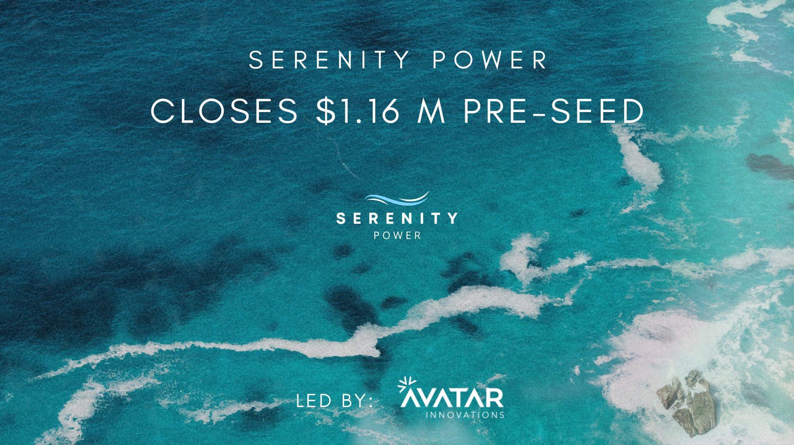

Toronto, ON — April 27, 2026 — Serenity Power, a Canadian climate-tech startup developing compact solid oxide fuel cell (SOFC) power systems, today announced the closing of its oversubscribed $1,165,000 CAD pre-seed funding round. The round was led by Avatar Ventures (“Avatar”) with participation from Antimo, rpv, Front Row Ventures, Rep Matters, The Firehood, and others.

Combined with previously secured non-dilutive funding, Serenity Power has now secured $2 million CAD in capital to accelerate the development of its first prototype systems and execute initial commercial pilots.

Serenity Power is engineering compact, affordable, fuel-flexible fuel cell systems that generate clean electricity using natural gas, hydrogen, methane, or blended fuels — enabling industries to replace diesel and conventional combustion generators with significantly lower-emission power.

Combustion generators remain a primary energy source for remote industrial operations, particularly across remote communities, oil and gas fields, construction sites, and off-grid infrastructure. These generators are costly, inefficient, and responsible for substantial emissions and air pollutants. Serenity Power’s systems provide reliable, distributed electricity with dramatically lower carbon intensity, helping energy producers, operators and distributors decarbonize locally without waiting for full grid electrification or the green hydrogen economy.

The female-founded company was launched in 2024 by co-founders who met in the engineering program at the University of Toronto Recognizing the opportunity to reduce emissions from industrial power generation, the team set out to commercialize next-generation fuel cell systems.



Serenity Power’s technology integrates advanced solid oxide fuel cells with an innovative reforming catalyst and intelligent system control, enabling simple and highly efficient power generation at the point-of-use. Serenity is focused on remote oil and gas sites, where legacy thermoelectric units, gas combustion, and diesel generation are still the norm, and is set to scale further across microgrids, utilities, data centres, and distributed power systems.
Since exiting stealth mode in 2025, Serenity Power has rapidly built momentum across the energy ecosystem and established a presence in Calgary, Alberta—Canada’s energy hub. The company has also secured non-dilutive funding from organizations including the Alberta Innovates, Mitacs, Innovation Asset Collective, Innovate Calgary, and NGIF Accelerator following extensive technical due diligence.
“By supporting the development of Serenity Power’s fuel cells, we are one step closer to increasing the efficiency of power sources used across the natural gas industry,” said John Adams, CEO of NGIF Accelerator. “Through our Industry Grants program, NGIF Accelerator helps de-risk emerging technologies through field trials and pilot projects, accelerating industry validation, customer adoption, and commercialization.”
Serenity marked a defining year in 2025, capturing major industry recognition across the innovation and climate-tech landscape. The team won the Catalyzing Canada Award at MaRS Climate Impact, earned the $100K Women in Tech Investment Prize (by The FIrehood in) at the Elevate Festival, and secured the $100K Black Entrepreneur Prize (by Rep Matters Angel Syndicate) at Startupfest. Serenity also took home Best Commercial Readiness at the Houston Climate & Energy Week Pilotathon, a standout endorsement of the company’s ability to turn bold innovation into market-ready impact.

The company has also secured multiple letters of intent for pilot deployments with major energy and infrastructure organizations, validating strong early demand for decentralized, low-emissions power solutions.

“Industries like oil and gas still rely heavily on conventional combustion to power remote operations, on both the small scale (watts) and larger scales (kilowatts),” said Aleisha Reese Cerny, CEO and co-founder of Serenity Power. “Our mission is to replace those generators with clean, fuel-flexible systems that can use the fuels already available on site, while providing a pathway to 100% zero-emission power.

In a moment when climate progress can feel uncertain, this investment is a powerful vote of confidence in climate-tech innovation. Today’s announcement is not only a milestone for Serenity, it’s a win for Canada’s climate-tech ecosystem. With the support of investors like Avatar, we can build our first system and deploy pilots with industry partners actively seeking scalable solutions to decarbonize operations. We couldn’t be more excited about what this means for the future of energy!”
“Serenity Power is a compelling example of how hardware innovation can be commercialized rapidly by targeting early adopters with urgent, real‑world needs.” said Bryan Trudel, Partner of Avatar Ventures Leadership Fund. “We are excited by the problem that Serenity is solving, distributed clean power, and are inspired by the team’s passion and dedication. Avatar is thrilled to lead this transaction and fill a critical gap in the early-stage hardware ecosystem, by providing Serenity Power with the necessary risk capital to achieve their near-term milestones, setting them up for long-term success”.
Proceeds from the pre-seed round will be used to build Serenity Power’s first working prototype, advance system engineering and integration, and execute initial field demonstrations with industry partners. The company is also expanding its engineering team and preparing for its next stage of commercialization.
Serenity Power is grateful to the key organizations that have supported its growth and early development, including the Clean Energy Zone, Science Discovery Zone, University of Toronto, ventureLAB, RXN HUB, and Altitude Accelerator. Serenity is active in both Toronto and Calgary, anchoring the company within Canada’s energy innovation ecosystem and supporting close collaboration with major industrial partners across North America and Europe.

About Avatar Ventures Leadership Fund
Anchored by a $750K lead investment from Cenovus Energy Inc. and supported by family offices and investors across Canada, the $2.5 million Avatar Ventures Leadership Fund provides early-stage risk capital to the most promising companies emerging from Avatar Studio, and a select few external start-ups. Its goal is to bridge the funding gap for promising energy transition technologies and accelerate Canada's decarbonization leadership.

About Serenity Power
Serenity Power is a Canadian climate-tech startup developing compact, fuel-flexible solid oxide fuel cell (SOFC) systems that generate reliable, low-emission electricity for distributed and industrial applications. The company’s technology enables industries to replace conventional combustion with efficient power systems that can run on natural gas, hydrogen, methane, or blended fuels. Serenity Power’s initial focus is decarbonizing remote oil and gas operations, with future applications across utilities, microgrids, data centres, and distributed energy infrastructure.

Media Contact
Aleisha Cerny, CEO, Serenity Power, https://serenitypower.ca

